06. Sequences

- Word Representation

Given a vocabulary of words, you can use 1-hot vectors o to represent the words. For example, the word "Apple" can be represented by the following vector.
$$o_{322}=\left[ \begin{aligned}0 \\ ⋮ \\ 0 \\ 1 \\ 0 \\ ⋮ \\ 0\end{aligned} \right] where 322 (the position of 1) is the index of "\text{Apple"} in the vocabulary$$

Another way to represent words is word embedding, which uses a set of features to represent a word. For example, the features can be: gender, age, food, size, color, and so on. Using these features, each word can be represented by a vector e which is called embedding vector. For example, "Apple" and "Orange" have similar vectors.
$$\text{"Apple"}=\left[ \begin{aligned}0.00 \\ 0.01 \\ 1.00 \\ 0.95 \\ 0.92 \\ ⋮\end{aligned} \right] "Orange"=\left[ \begin{aligned}0.05 \\ 0.03 \\ 0.90 \\ 0.95 \\ 0.95 \\ ⋮\end{aligned} \right]$$

Word embeddings usually learn from very large text corpus, for example, 10 billion words. You can download pre-trained embedding models online and transfer it to new tasks with smaller training set. If you also have large dataset, you can continue to finetune the word embeddings with your new data.

- Word Embedding

Given a vocabulary of $n$ words and $m$ features, there are many ways to find the embedding matrix $E=\left[e_{1}, e_{2}, …, e_{n}\right]$. The following shows how to use the last four words before the target word to predict it.
$$\left[ \begin{aligned}a \\ glass \\ of \\ orange\end{aligned} \right]→\left[ \begin{aligned}o_{1} \\ o_{3852} \\ o_{6163} \\ o_{6257}\end{aligned} \right]→E→\left[ \begin{aligned}e_{1} \\ e_{3852} \\ e_{6163} \\ e_{6257}\end{aligned} \right]→\left[ \begin{aligned}O \\ O \\ O \\ O\end{aligned} \right](NN)→softmax→o_{3965} ("juice")$$

If you want to build a language model, you can use the last few words as a context. If you want to learn a word embedding, you can use the last four words, four words on the left and four words on the right, the last one word, or even one word nearby. They call can result in very meaningful work embeddings.

Word2Vec Model

The algorithm randomly chooses a word ("glass") as the context word, and then chooses another word ("juice") within a window (for example, [-5, +5] or [-10, +10]) to be the target word.
$$"glass"→o_{3852}→E→e_{3852}→softmax→o_{3965} ("juice")$$

The following shows the softmax model. Here t means target, c means context, $θ_{t}$ is a parameter associated with output, 10000 is the size of the vocabulary.
$$p\left(t | c\right)=\frac{e^{{θ_{t}}^{T}∙e_{c}}}{\sum_{j=1}^{10000}{e^{{θ_{j}}^{T}∙e_{c}}}}$$

Negative Sampling

First we pick a context word and a target word from the sentence to make a positive example and label it with 1. Then use the same context word, pick k words from the vocabulary to make k negative examples (the word may be in the sentence too) and label them with 0. For large dataset, k = [2, 5]; for small dataset, k = [5, 20].
Context | Target | Prediction
orange | juice | 1
orange | king | 0
orange | the | 0
$$⋮$$ | $$⋮$$ | $$⋮$$

Next you can build a logistic regression algorithm to train the dataset. Negative sampling is much cheaper than Word2Vec. The following shows how to select the negative examples.
$$p\left(w_{i}\right)=\frac{f{(w_{i})}^{3/4}}{\sum_{j=1}^{10000}{f{(w_{j})}^{3/4}}}$$

GloVe Algorithm

GloVe stands for "Global Vectors for word representation". This algorithm defines $X_{i,j}$ to specify the number of times that word $j$ appears in context of word $i$, and optimize the following expression where $f(X_{i,j})$ is a weighting function that gives different amount to frequent words and infrequent words. In addition, $f\left(X_{i,j}\right)=0$ if $X_{i,j}=0$ (in this case, $\log{X_{i,j}}$ will be negative infinity).
$$minimize \sum_{i=1}^{10000}{\sum_{j=1}^{10000}{f(X_{i,j})∙{\left({θ_{i}}^{T}e_{j}+b_{i}+{b_{j}}^{'}-\log{X_{i,j}}\right)}^{2}}}$$

- Cosine Similarity

To measure the similarity between two words, we need a way to measure the degree of similarity between two embedding vectors for these two words. The most common similarity function is Cosine Similarity.
$$cosine_similarity\left(u,v\right)=\frac{u∙v}{{\left\|u\right\|}_{2}*{\left\|v\right\|}_{2}}, where {\left\|u\right\|}_{2}=sqrt\left(\sum_{i=1}^{n}{{u_{i}}^{2}}\right)$$

Given two vectors $u$ and $v$, if $u$ and $v$ are very similar, their cosine similarity will close to 1. If they are dissimilar, the cosine similarity will be a smaller value.

Let's use $e_{w}$ to represent the embedding vector of word $w$. Given a question: "Man to woman as king to w ?", we can convert it to "Find word $w$ so that $cosine_similarity(e_{woman}-e_{man}, e_{w}-e_{king})$ is maximum". It is easy to look through the whole vocabulary to find word $w$.

- Sentiment Classification

Given a piece of text, tell if someone likes or dislikes the thing that they are talking about. This is called Sentiment classification. The following shows some examples:
The dessert is excellent. ♥♥♥♥♥
Service was quite slow. ♥♥
Good for a quick meal, but nothing special. ♥♥♥

The following shows the neural network.
$$\left[ \begin{aligned}The \\ dessert \\ is \\ excellent\end{aligned} \right]→\left[ \begin{aligned}o_{8928} \\ o_{2468} \\ o_{4694} \\ o_{3180}\end{aligned} \right]→E→\left[ \begin{aligned}e_{8928} \\ e_{2468} \\ e_{4694} \\ e_{3180}\end{aligned} \right]→average→softmax→\hat{y}$$

The following shows the algorithm.
- For $t=1 to iterations:$
For $i=1 to m:$
For input $x^{(i)}$, convert each word into the corresponding word vector representations.
Compute the average of the word vectors.
Compute $z, a, cost$ using forward propagation.
Compute $dz, dW, db$ using backpropagation.
Update parameters $W, b$.
- Given an input, predict it by finding the maximum value from the output.

The algorithm above ignores word ordering. To account for the word ordering, you can use LSTM. LSTM requires that every input has the same length. You can first find the longest sentence in the training set, and pad every sentence with "0" so that each input sentence has the same length.

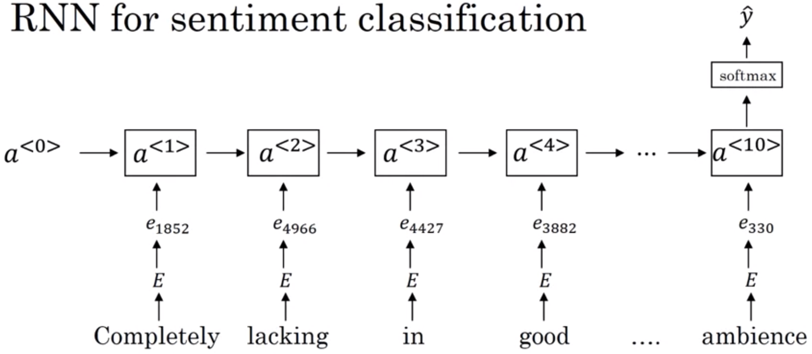

- Debiasing Word Embedding

The following shows how to neutralize "doctor" and "babysitter", and equalize "grandfather" and "grandmother".

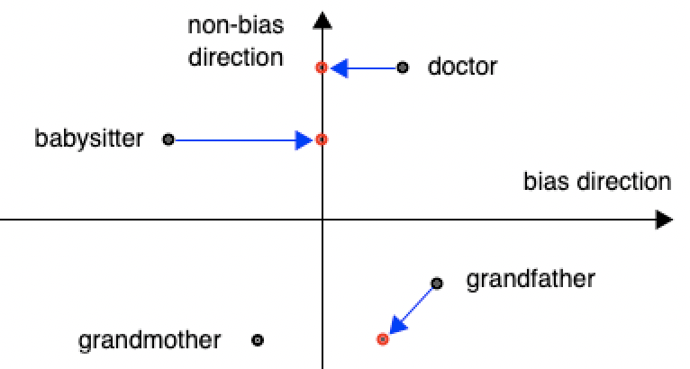

The following shows how to debias word embeddings.
- Identify bias direction. For example, for gender, we compute the average of the difference as follows.
$$average(e_{he}-e_{she}, e_{male}-e_{female}, …)$$

- Neutralize. For every word that is not definitional, project to get rid of bias. For example, we move the nondefinitional words "babysitter" and "doctor" to the non-bias direction axis.
$$e^{bias_component}=\frac{e∙g}{{\left\|g\right\|}_{2}^{2}}*g where bias axis g=e_{grandfather}-e_{grandmother}$$
$$e^{debiased}=e-e^{bias_component}$$

- Equalize pairs. For example, we move "grandfather" and "grandmother" and make them the same distance to the non-definitional words, such as "doctor" and "babysitter".
$$μ=\frac{e_{w1}+e_{w2}}{2} where e_{w1}="doctor" and e_{w2} ="babysitter"$$
$$μ_{B}=\frac{μ∙g}{{\left\|g\right\|}_{2}^{2}}*g$$
$$μ_{⊥}=μ-μ_{B}$$
$$e_{w1B}=\frac{e_{w1}∙g}{{\left\|g\right\|}_{2}^{2}}*g$$
$$e_{w2B}=\frac{e_{w2}∙g}{{\left\|g\right\|}_{2}^{2}}*g$$
$$e_{w1B}^{corrected}=\sqrt{\left|1-{\left\|μ_{⊥}\right\|}_{2}^{2}\right|} *\frac{e_{w1B}-μ_{B}}{\left\|\left(e_{w1}-μ_{⊥}\right)-μ_{B}\right\|}$$
$$e_{w2B}^{corrected}=\sqrt{\left|1-{\left\|μ_{⊥}\right\|}_{2}^{2}\right|} *\frac{e_{w2B}-μ_{B}}{\left\|\left(e_{w2}-μ_{⊥}\right)-μ_{B}\right\|}$$
$$e_{1}=e_{w1B}^{corrected}+μ_{⊥} (new word vector of w1)$$
$$e_{2}=e_{w2B}^{corrected}+μ_{⊥} (new word vector of w2)$$

- Sequence to Sequence

One example of sequence to sequence model is language translation, for example, given a sentence in French, translate it into English. The input and the output have different length.
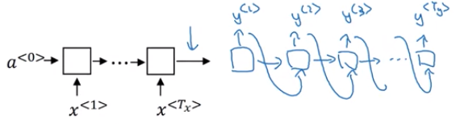

This architecture is called Encoder-Decoder architecture. Another example of sequence to sequence model is image captioning, for example, given an image, tell the meaning.

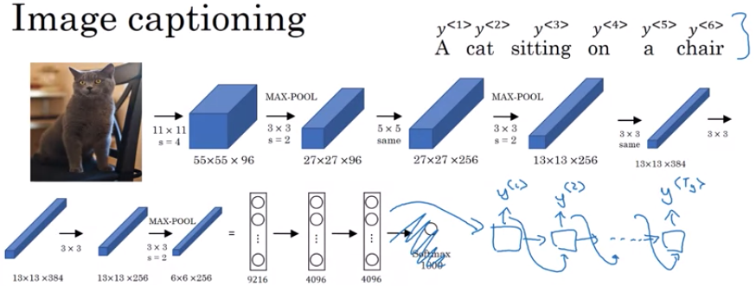

- Beam Search Algorithm

Beam search algorithm uses a parameter $B$ which is called beam width. Whereas Greedy search always picks the most likely word, beam search algorithm picks $B$ (usually 10) words with the highest probability at every step to consider. For example, the first step picks three with the highest probability, and the second step picks 3 with the highest probability based on the three words picked at the first step.
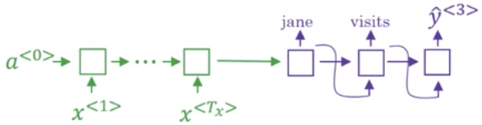

The probability of the output to choose should be:
$$\max_{y}{\prod_{t=1}^{T_{y}}{P\left(y^{<t>}|x, y^{<1>},…,y^{<t-1>}\right)}}$$

Since $P≤1$, shorter outputs will be preferred, so we use the sum expression and sentence normalization.
$$\max_{y}{\frac{1}{{T_{y}}^{α}}∙\sum_{t=1}^{T_{y}}{\log{P\left(y^{<t>}|x, y^{<1>},…,y^{<t-1>}\right)}}} where 0≤α≤1 (usually 0.7)$$

- Attention Model

When you translate a paragraph from French to English, you don't have to read the whole paragraph. The attention mechanism tells a neural network where it should pay attention to at any step.
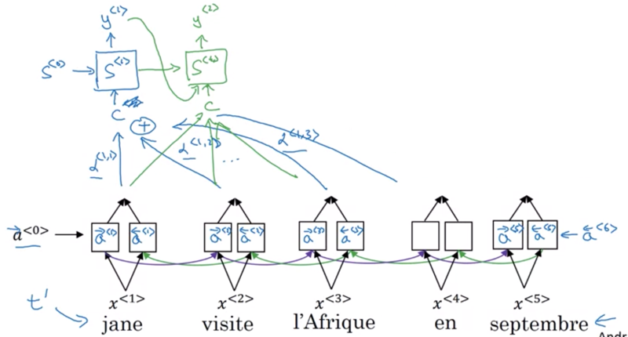

Let $t^{'}$ to be the index of the input. The output of the bidirectional RNN $a^{<t^{'}>}=\left[{\vec{a}}^{<t^{'}>},{\overset{⃖}{a}}^{<t^{'}>}\right]$ where ${\vec{a}}^{<t^{'}>}$ and ${\overset{⃖}{a}}^{<t^{'}>}$ are the hidden states of the forward-direction and backward-direction of the LSTM, respectively. The parameter $α^{<t, t^{'}>}$ is the amount of "attention" that $y^{<t>}$ should pay to $α^{<t^{'}>}$. For any $c^{<t>}$, the sum of $α^{<t, t^{'}>}$ is equal to 1. For example, for the first output $c^{<1>}$, we have:
$$\sum_{t^{'}}{α^{<1, t^{'}>}}=1$$
$$c^{<1>}=\sum_{t^{'}}{α^{<1, t^{'}>}∙a^{<t^{'}>}}$$

The following shows the formula to compute these attention weights $α^{<t, t^{'}>}$.
$$α^{<t, t^{'}>}=\frac{exp\left(e^{<t, t^{'}>}\right)}{\sum_{t^{'}=1}^{T_{x}}{exp\left(e^{<t, t^{'}>}\right)}}$$

We use a small neural network to compute $e^{<t, t^{'}>}$. The hidden state $s$ is initialized with 0.
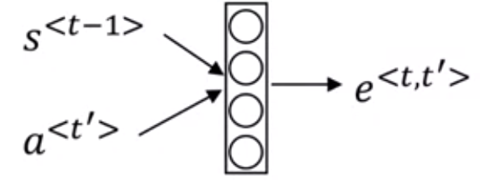

The following shows the attention model.
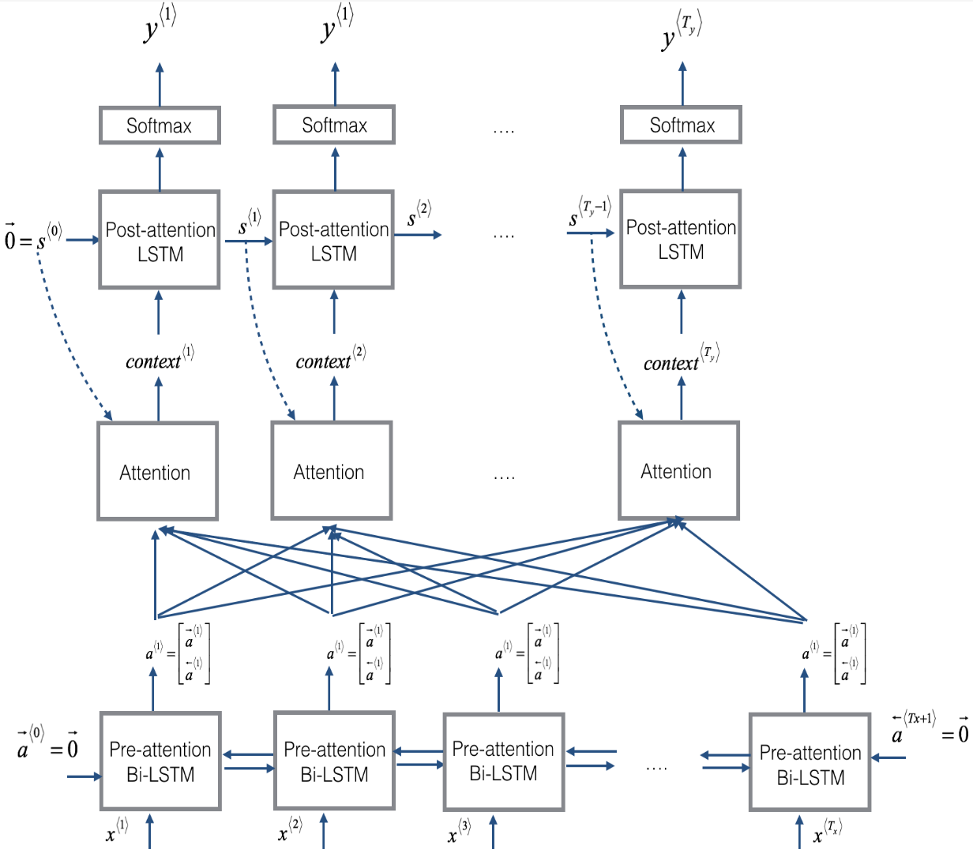

- Speech Recognition

Given an audio clip, a speech recognition algorithm automatically outputs a text transcript. The following shows an attention model for speech recognition system. The inputs are different time frames of the audio.
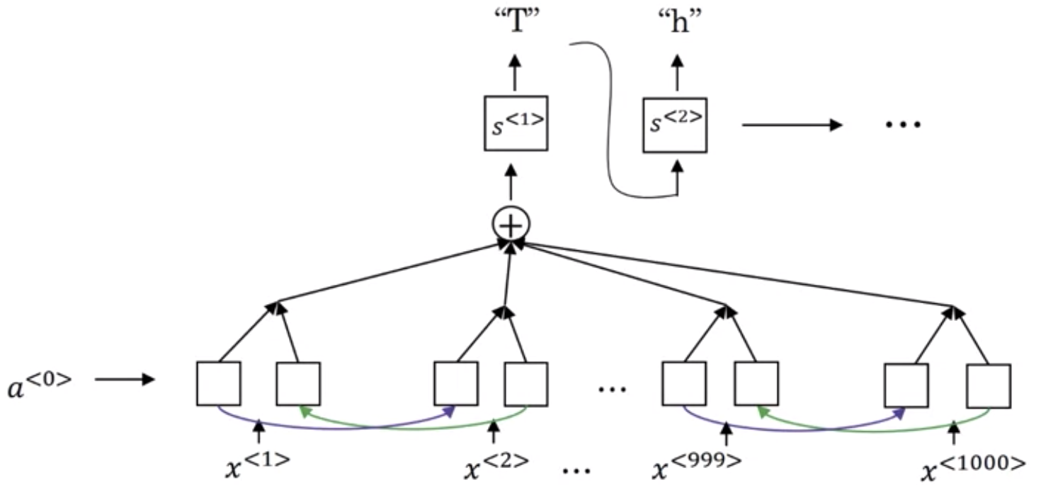

Another method is called CTC, in which input $x$ and output $y$ has the same length.
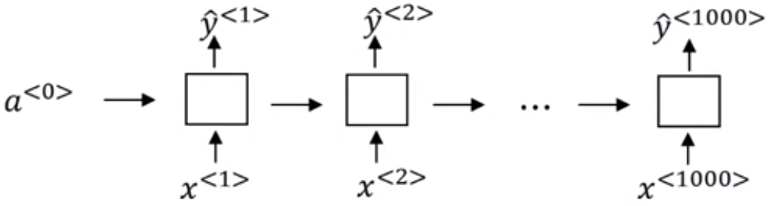

Since the number of time steps is very large and usually much bigger than the output time steps. The CTC cost function allows the RNN to generate outputs like: "ttt_h_eee___ ___ccc__aa__ttt". After collapsing the repeating characters, the output will be "the cat".

- Trigger Word Detection

In the trigger word detection algorithm, when the trigger word is input, it outputs one (or multiple) 1; otherwise, 0.
